Who’s That Horse?
Horse Breeds of the World
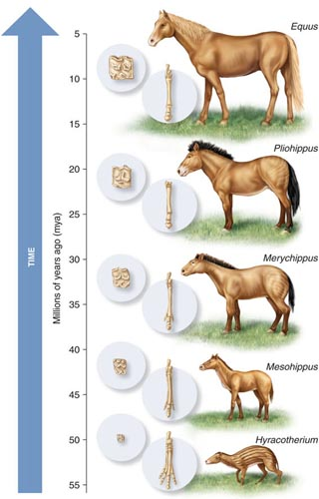
Figure 1. Evolution of the horse. Source: Delta State University
Many paleontologists consider Hyracotherium the first ancestor of modern horses (Figure 1). Hyracotherium or the “Dawn Horse” lived 55 million years ago. Hyracotherium stood 12-14 inches high, had four hoofed toes on its front feet, three hoofed toes on its hind feet, and fed on soft leaves and plant shoots. It took around 45 million years for the first horse to evolve into the modern horse (Equus caballus), we have today.

About 3,000 years ago, people began domesticating the horse and selecting and breeding for traits that were important to them. As a result, different breeds of horses were developed to provide food (meat and milk), transportation, sport, and recreation. Breeds are identified by their unique characteristics which help make them easier to recognize.

Today, there are more than 350 breeds of horses in the world that come in a variety of shapes, sizes, and colors. Learning a horse’s body parts helps to understand breed characteristics (Figure 2).

Using all of these characteristics, let’s explore the world of horse breeds and answer the question: Who’s That Horse?
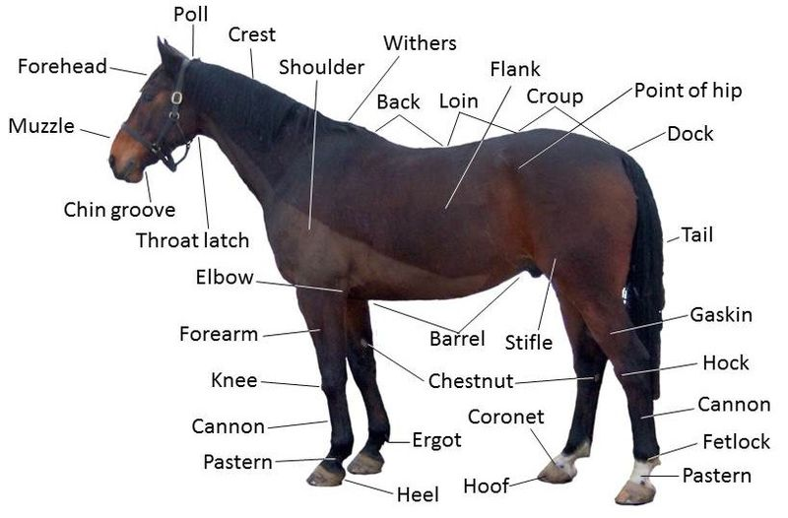

Figure 2. Parts of a Horse
Source: The Habitat for Horses.org.

The University of Kentucky has an excellent Interactive Horse that will help students learn the body parts and can be accessed at http://www2.ca.uky.edu/agripedia/agmania/interactive/horse.htm

- A Horse of a Different Color

Horses come in a variety of colors caused by the expression or suppression of genes. There are five basic horse coat colors and five major variations of coat colors. See attached American Quarter Horse Association Color and Markings Reference Chart. Download for free at: http://americashorsedaily.com/horse-color-and-markings-chart/.

Five Basic Coat Colors
- Bay-A mixture of red and yellow, about the color of a well-baked loaf of bread. Bays always have black points (mane, tail, legs).
- Black-Eyes, hoofs, and skin are black. Those with brown hairs on the muzzle and flanks are not true blacks.
- Brown-All hair (body, muzzle, mane and tail) is brown.
- Chestnut (Sorrel)-A wide variety of colors but the hair is red and the mane and tail will be the same as the body color or lighter. All of these horses will have black or brown skin.
- White-True white horses are born white and die the same color.

Five Major Variations to Coat Colors
- Dun (Buckskin)-Hair color can vary but the dominant color is a shade of yellow. All duns have a stripe down their back.
- Grey-Born blue or almost black. White hairs increase until the horse will appear almost white by 8-10 years of age.
- Palomino-Body color is a golden shade with a white mane and tail. There are no black points.
- Pinto-A spotted horse with more than one color in or on its coat in large irregular patches.
- Roan-Horses with coat colors that are usually bay, chestnut or black with white hairs mixed in.

- Markings

In addition to coat colors, horses may carry white markings on their face and legs. These markings provide character and sometimes help in naming the horse. For example, a horse that has a “star” on its forehead, may be called “Star”.

Head (See Figure 3)
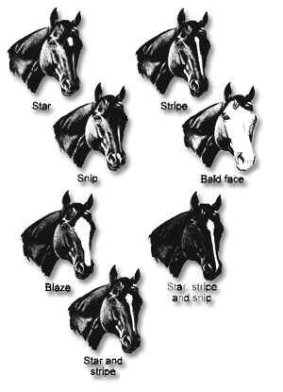
Figure 3. Horse head markings.
Source: Florida 4-H horse project.

- Star-Small, clearly defined area of white hairs on the forehead.
- Snip-Small patch of white that runs over the muzzle, often to the lips.
- Stripe-A long narrow band of white that runs from the forehead toward the muzzle.
- Blaze-A white stripe down the face to the lips.
- Bald-White over most of the face, usually extending past the eyes toward the cheeks.

Legs
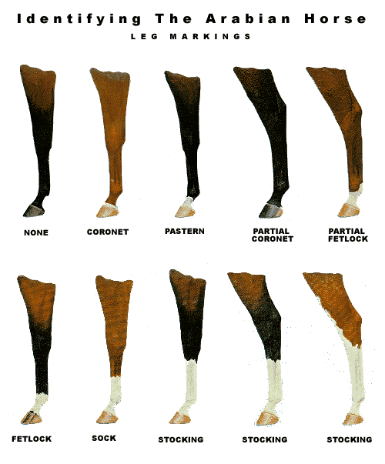
Figure 4. Horse leg markings.
Source: Arabian Horse Association

- Coronet-White strip covering the coronet band, above the hoof.
- Pastern-White band extends to and includes the pastern.
- Fetlock or Ankle-White runs from coronet to above the fetlock.
- Sock-White runs from coronet halfway up the cannon bone.
- Stocking-White runs from coronet band to just below (half) or above (full) the knee or hock.

- Horse Breeds

Since there are more than 350 breeds of horses in the world, covering them all may be a challenge. As a result, this lesson includes selected breeds from around the world. Or you can use the following websites as reliable sources of descriptions and photos for many of the breeds. We highly recommend Sam Savitt’s posters and books as his attention to artistic detail and accuracy with horses is exceptional.

- HorseChannel.com
- Oklahoma State University, Breeds of Livestock, Department of Animal Science, Horses: http://www.ansi.okstate.edu/breeds/horses
- Sam Savitt’s Art and Books: http://www.samsavitt.com/index.html

Select Breeds of Horses

- Akhal-Teke-This horse descended from the ancient Turkmenian horse which was one of the four original horse "types" that crossed the Bering Strait from America to Russia in prehistoric times. These horses have superb gates, great stamina and courage, were used as cavalry mounts and racehorses, and are native to a dry and barren environment.

- American Paint Horse- Decorated by nature, the origins can be traced back to the two-toned horses (white and dark) introduced by the Spanish explorers. Coat colors are defined at tobiano or overo and can be lack, bay, brown, chestnut, dun, grulla, sorrel, palomino, gray or roan. Favored by the Native Americans and early cowboys.

- American Quarter Horse- So called because of its great speed at one quarter of a mile. Developed in the United States, the Quarter Horse is a mix of breeds, most notably the thoroughbred. Over time, they were developed to create the ideal stock horse for ranch and cattle work. They come in a variety of colors and are used for racing, ranching, trail riding, jumping, dressage and more. The American Quarter Horse Association is the world’s largest equine breed registry. This horse is often called “American’s Horse”.

- Andalusian- This breed originated in and gained its name from the Spanish Province of Andalusia. Its ancestors are the Iberian (Spanish) horse and the Barb horse which was brought to Spain by invading Moors. They have a distinguished appearance, usually in the colors white and light gray, and occasionally bay. It is the original horse used for the art of dressage.

- Appaloosa-This breed was developed by the Nez Perce of Washington, Oregon and Idaho and were prized and envied by other Native American tribes. Appaloosas are most commonly recognized by their blankets of spots which can be all over their body or just the back half. Other distinguishing features are mottled skin, white sclera (around eyes), and striped hooves.

- Arabian - The Bedouin tribes of the Arabian Desert told many romantic tales of the Arabian's beginnings. The Arabian was bred to withstand long treks across the desert and during the tribal wars which sometimes followed such trips. The Arabian's head has a characteristic dished profile with a prominent eye, large nostrils and small teacup muzzle.

- Australian Stock Horse- Since 1788, the Australian Stock Horse has evolved through selective breeding to be able to withstand the harsh environment, travel long distances day after day, and remain a reliable mount. One popular movie that depicts these horses and their abilities is "The Man from Snowy River".

- Bashkir Curly-Recognizable by their extremely curly coat, the origin of these horses is unknown. Modern day American history dates them to 1898 when they were discovered in the remote high country of Nevada. One especially odd feature of the breed is the fact that they can completely shed out the mane hair (and sometimes even the tail hair) each summer, to grow back during the winter.

- Cleveland Bay- This horse is the oldest established breed of English Horse and is unique in its carefully maintained purity (no crossing with other breeds). They come from Cleveland in the North East of England and became popular as driving horses. These horses are always bay in color.

- Clydesdale- A heavy draft horse developed in and deriving its name from, the district region in Scotland where it was founded. Bred for work on the farms and in the coal mines, Clydesdales are known for their size, power, and strength. Their most recognizable features are the long white hairs, known as feather, on all four legs. The Budweiser Clydesdales are the most famous in the world.

- Falabella-Originating in Argentina from the Andalusians brought to the continent by Spanish explorers, this rare breed of miniature horses possesses all the features and attributes of its taller relatives. One of the smallest of horses, this breed is seldom over 8 hands high (32 inches) and often lives to be 40-45 years old.

- Friesian-This is one of the oldest domesticated breeds in Europe. It is native to the province of Friesland in the northern Netherlands. Common in circuses, its outstanding characteristics are a very long mane and tail (can reach the ground) and abundant feathering on the legs. The color is always black, and only a white star on the forehead is permissible.

- Gypsy Vanner- The Gypsies of Great Britain bred Shire, Clydesdale, Dales Ponies and Friesian horses to create the perfect caravan horse. These horses resemble a small draft horse but with more feathering on the legs, more color and a “sweeter head”. Piebald and skewbald are common coat colors.

- Haflinger-This old breed of small horse originated in the mountains of the Austrian Tyrol. The name comes from the village of Hafling, part of Austria prior to the end of World War I, but now, located in Italy. Color may range from pale chestnut to dark liver chestnut with a pale mane and tail. This horse has a stout, athletic appearance, is from 54 to 60 inches at the withers, and is used for riding, driving, and pulling.

- Hanoverian-These horses were developed in Lower Saxony, Germany. Hanoverian’s are a noble, correctly proportioned, warmblood horse with natural balance, impulsion and elegant, elastic movements. Their gaits are characterized by a floating trot, a round rhythmic canter, and a ground-covering walk. They are most notable for their appearance in the dressage competition of the summer Olympics.

- Icelandic-Known in Iceland as Islenzki hesturinn, the Icelandic horse is descended from horses brought to Iceland by settlers over eleven centuries ago. This horse is small, sturdy, hardy, and lively in temperament. Traditionally raised free range, average height is between 13 and 14 hands. Famous for the “tolt” which is an even 4 beat, supple, high action gait that has long strides. All colors are found (except appaloosas), all markings are acceptable, the horses have long, thick manes and tails and double winter coats.

- Marwari- A rare breed from the Marwar region of India that is easily identified by its inward-curving ears. The breed has been around since early in the 12th century, and is a hardy sport horse that was mainly used as a cavalry horse throughout its history. Today it is used mostly for farm work, riding and packing.

- Lipizzan or Lipizzaner-These horses trace their history back to the early 1560's when Arab horses were bred with local Spanish horses during the Moorish occupation of Spain. Born dark, black-brown, brown or mouse-grey, Lipizzans turn white somewhere between the ages of 6 and 10. These horses are famous for classical horsemanship and the maneuvers dubbed the “Airs Above the Ground”.

- Missouri Fox Trotting Horse- This horse was developed in the rugged Ozark hills during the 19th century by settlers who needed easy riding, durable mounts that could travel long distances at a sure-footed, ground consuming gait. The distinguished characteristic of the Missouri Fox Trotting Horse is the Fox Trot gait; the horse walks with the front feet and trots with the hind feet.

- Mongolian- One of the most important and numerous breeds found among the indigenous horse breeds of China. It is a dual-purpose horse, used primarily for riding and carting, but is also used for meat and milk production.

- Morgan-This breed began in Vermont in 1789 with a stallion known as “Figure” who was owned by a man named Justin Morgan. These small horses are known for their beauty and strength and excel at both riding and driving.

- Mustang-This is a feral horse in the western United States. The name Mustang comes from the Spanish word mesteño or monstenco meaning wild or stray. Descended from Spanish horses whose foals were mixed with various breeds, these were the horses which changed the lives of the Native Americans living in or near the Great Plains. The Mustang are protected by federal law and managed by the Bureau of Land Management. They are available for adoption.

- Norwegian Fjord-The Norwegian Fjord (pronounced Fee-ord) is Norway's oldest horse breed. This pony was used by the Vikings for war mounts and farming. These dun colored horses have a dark dorsal stripe that runs from the crest of the mane, along the back, and to the tail; dark colored bars on the legs; and dark fetlocks.

- Paso Fino-This breed began in Spain and is a combination of the native Berber (Barb) and Andalusian horses. Christopher Columbus was the first to bring the ancestors of these horses to the new world on his second voyage. This horse is most famous for its numerous, smooth four-beat gaits. The basic gaits in order of speed (fast to slow) are the paso fino, paso corto, and paso largo.

- Percheron-Of unknown origins, these horses got their name in the 17th century because they were produced in the Le Perche Region of France. After being imported to the US in the late 1800’s, the breed became the favorite of both the American farmer and the teamster who moved freight on the nation’s city streets. Percherons are known for their black or dappled grey coloring and are shown in competition hitching and halter classes at many state and county fairs across the country.

- Shire-These large, heavy horses come in the preferred colors of black, brown, bay, gray, or chestnut/sorrel (rare) with feathering on their legs. They average 17.1 hands tall and are considered the largest horses in the world. Originally developed to carry a horse soldier whose armor weighed up to 400 pounds, these powerful horses have war in their ancient heritage. The breeds name comes from the counties in England ending in “shire”, i.e, Yorkshire.

- Standardbred-Considered to be the fastest harness horse in the world. The breed resembles its ancestor the Thoroughbred. It gained its name from the fact that a horse must meet a certain "standard" of either timed speed at the mile or breeding in order to be properly registered. The most famous sire of Standardbreds was Hambletonian and 90% of Standardbreds can trace their genealogy back to him.

- Tennessee Walking Horse (TWH) - Over one hundred years ago, in the Middle Basin of Tennessee, this unique breed was created from Standardbreds, Morgans, Thoroughbreds, Canadian and Narrangasett Pacers. They are known for their “running walk” where they can travel 6-12 mph, their bold “flat-foot walk”, and their “rocking chair” canter. TWH’s come in all colors and have long, flowing manes and tails. They are mainly used for riding and driving but also on ranches and farms.

- Thoroughbred-The term Thoroughbred describes a breed of horse whose ancestry traces back to three foundation sires -- the Darley Arabian, the Godolphin Arabian and the Byerly Turk. The result was an animal which could carry weight with sustained speed over extended distances. Thoroughbreds became popular for flat racing known as “the sport of kings”. Each year, eligible 3 year-old horses try to win the Triple Crown (Kentucky Derby, Preakness, and Belmont). Unique to this breed, every thoroughbred registered with the Jockey Club has its birthday on January 1, regardless of the day it was born.

- Welsh Cob-A native of the Welsh Mountains in Wales, Great Britain. This sturdy pony was known for climbing mountains, leaping ravines, and running over rough terrain. These ponies are strong of spirit but obedient, with great beauty and refinement

- Activities
  - Grades K-3: Matching game using colors, markings, or breeds. Also, a great lesson to use is a Virginia 4-H horse activity titled: A Horse of a Different Color which can be found at: http://pubs.ext.vt.edu/380/380-104/380-104_PDF.pdf

  - Grades 3-5: Research breeds and make a new breed using two different breeds. Provide a description of the new breeds with information about all the benefits of the new breed. For example, a Tennessee Walking Horse crossed with a Quarter Horse could be a “Quarter Walker”.

  - Grades 6-8: Use the following poem to identify some common breeds of horses. Write your own poem or story about a breed.

Who Am I?
I was the first,
No bigger than a fox. ______________________________
I have four toes, (Hyracotherium-“Dawn Horse”)
But wear no socks.

I’m a horse who flies without wings, ______________________________
I race on a track in the “Sport of Kings”. (Thoroughbred)
All our birthdays are on New Year’s Day,
Jockeys guide us and grooms feed us hay.

I’m America’s favorite,
Because, I’m strong, fit and won’t quit.
At a quarter mile I can’t be beat, ______________________________
I work cattle on ranches in snow, rain, and heat. (American Quarter Horse)

I’m considered rare, _______________________________
My ears they do curl. (Marwari)
As I carried the cavalry,
Their flag would unfurl.

When riding me you “rock in a chair”, _______________________________
While the breeze blows through my beautiful hair. (Tennessee Walking Horse)
I’m unique to a state that begins with a “T”,
For riding and driving, depend upon me.

I come from the land of fire and ice, _______________________________
My double winter coat sure feels nice. (Icelandic)
I’m famous for my 4-beat “tolt”,
I may be lively, but I never bolt.

  - Other Options:
    - Use breeds as a geography lesson since they have been developed around the world.
Developed by Georgette Plaugher, Georgy.Plaugher@ mail.wvu.edu

